**Name: Saqib Shehzad**

**Roll No. : 2021-CS-187**

3. cat command is used to view the contents of a file.

First file :

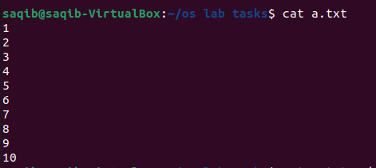

Second File :

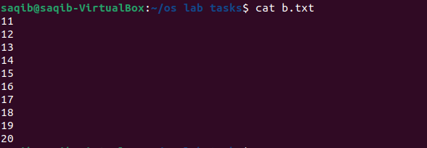

Code for joining two files : cat file1.txt >> file2.txt

After combining two files :

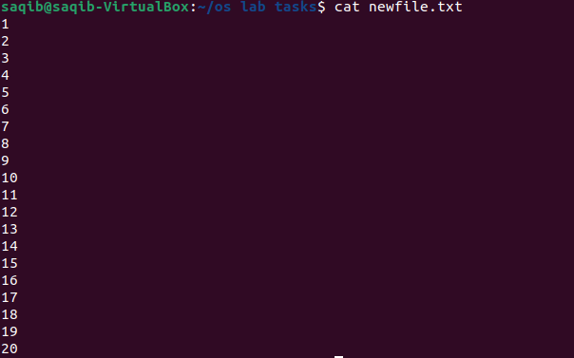

First two lines of first file :



last two lines of second file :



For finding a string :

Code : grep “String name “ filename.txt



For Granting permission to the to the group for 2nd file to execute :



After granting permission check how many people have or watching :



For removing the write permission for the owner for 2nd file :



For checking where the user is currently working :



For Seeing the all files on desktop Directory first we have to move on to the desktop directory and then by using **ls –a** command we will list all the files of Desktop

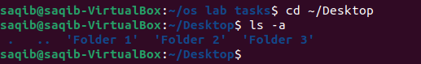

For making the folder we will use **mkdir** command :

